**Insert School Logo**

**Semester One**

**Examination 2020**

**Question/Answer booklet**

**MATHEMATICS**

**METHODS UNIT 3**

**Section Two:**

**Calculator–assumed**

|  |
| --- |
| Student Name: _____________________________________ |
| Teacher’s Name: _____________________________________ |

**Time allowed for this section**

Reading time before commencing work: ten minutes

Working time for paper: one hundred minutes

**Material required/recommended for this section**

**To be provided by the supervisor**

This Question/Answer booklet

Formula Sheet (retained from Section One)

**To be provided by the candidate**

Standard items: pens (blue/black preferred), pencils (including coloured), sharpener, correction tape/fluid, erasers, ruler, highlighters

Special Items: drawing instruments, templates, notes on two unfolded sheets of A4 paper, and up to three calculators approved for use in the WACE examinations.

**Important note to candidates**

No other items may be taken into the examination room. It is **your** responsibility to ensure that you do not have any unauthorised notes or other items of a non–personal nature in the examination room. If you have any unauthorised material with you, hand it to the supervisor **before** reading any further.

**Structure of this paper**

|  |  |  |  |  |  |
| --- | --- | --- | --- | --- | --- |
|  | Number of questions available | Number of questions to be attempted | Working time (minutes) | Marks available | Percentage of exam |
| Section One  Calculator—free | 7 | 7 | 50 | 50 | 35 |
| **Section Two**  **Calculator—assumed** | **11** | **11** | **100** | **100** | **65** |
|  | | | | Total Percentage | 100 |

**Instructions to candidates**

1. The rules for the conduct of Western Australian external examinations are detailed in the

*Year 12 Information Handbook 2020.* Sitting this examination implies that you agree to abide by these rules.

1. Answer the questions according to the following instructions.

**Show all your working clearly.** Your working should be in sufficient detail to allow your

answers to be checked readily and for marks to be awarded for reasoning. Incorrect answers given without supporting reasoning cannot be allocated any marks. For any question or part question worth more than two marks, valid working or justification is required to receive full marks. If you repeat an answer to any question, ensure that you cancel the answer you do not wish to have marked.

It is recommended that you **do not use pencil**, except in diagrams.

1. You must be careful to confine your responses to the specific questions asked and to follow any instructions that are specific to a particular question.
2. Spare pages are included at the end of this booklet. They can be used for planning your responses and/or as additional space if required to continue an answer.

* Planning: If you use the spare pages for planning, indicate this clearly at the top of the page.
* Continuing an answer: If you need to use the space to continue an answer, indicate in the original answer space where the answer is continued, i.e. give the page number. Fill in the number of the question that you are continuing to answer at the top of the page.

1. The Formula Sheet is **not** handed in with your Question/Answer Booklet.

# Section Two: Calculator–assumed 65% (100 marks)

This section has **eleven (11)** questions. Attempt **all** questions. Write your answers in the spaces

provided.

Spare pages are included at the end of this booklet. They can be used for planning your responses

and/or as additional space if required to continue an answer.

* Planning: If you use the spare pages for planning, indicate this clearly at the top of the page.
* Continuing an answer: If you need to use the space to continue an answer, indicate in the original answer space where the answer is continued, i.e. give the page number. Fill in the number of the question(s) that you are continuing to answer at the top of the page.

Working time: 100 minutes

**Question 8 (9 marks)**

Fifty patients were asked their waiting times, to the nearest five minutes, at a doctor’s surgery.

The results are shown in the table below.

|  |  |  |  |  |  |
| --- | --- | --- | --- | --- | --- |
| Number of minutes waiting | 5 | 10 | 15 | 20 | 25 |
| Number of patients | 6 | 8 | 10 | **a** | **b** |

(a) The expected value of waiting times is 16.6 minutes.

Show that **a** = 16 and **b** = 10. (4 marks)



(b) Determine the standard deviation of the waiting times. (2 marks)

If an extra doctor is added to the roster waiting times are reduced by d%.

(c) Calculate, in terms of d, the new:

(i) expected value of the waiting time. (1 mark)

(ii) variance of the waiting times. (2 marks)

**Question 9 (10 marks)**

The function y = f (x) has the following features.

f ′(−2) = f ′(2) = f (0) = 0

f (−2) = −2, f (2) = 2

f ′(x) > 0 for −2 < x < 2

f ′(x) < 0 otherwise

(a) Draw a possible sketch of y = f (x) on the axes below. (4 marks)

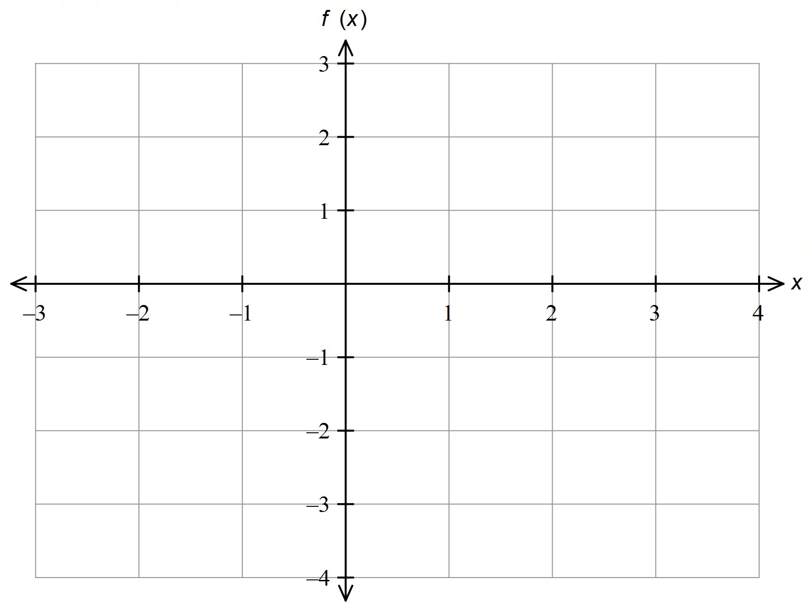

(b) Determine, with working, the exact value of:

(i) 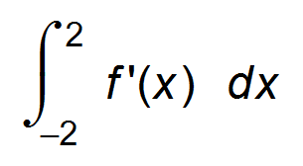 (2 marks)

(ii) 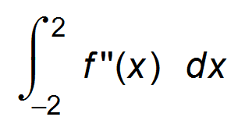 (2 marks)

(ii) the area bounded by the curve y = f ′(x), the x−axis and the lines x = −2 and x = 2.

(2 marks)

**Question 10 (10 marks)**

A pathologist extracts a micro−organism from a culture. There are 2 million microbes in the extract

at 12:30 pm. By 12:35 pm the extract has grown to 2.5 million.

(a) Determine the equation for exponential growth which models the number of microbes (*M*)

in the extract at any time, *t* minutes after 12:30 pm, in the form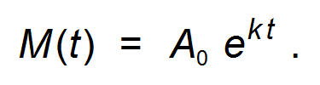

Give the value of *k* to four significant figures. (3 marks)



(b) Use the *k* value, to four significant figures, to determine how many microbes, correct to the nearest 500, are expected to be in the extract by 12:45 pm? (2 marks)

(c) What is the rate of change in the population at 12:45 pm? (2 marks)

At 12:45 pm, the extract is cooled so that the population of microbes decreases by 5% per minute.

(d) At what time will the population first be restored to 2 million? (3 marks)

**Question 11 (10 marks)**

The two poles shown below, one of length 4 m and the other of length 10 m, are 30 m apart.

A wire is attached to the top of each pole and anchored to the ground between the poles.

Let the angle between larger pole and the wire be θ, and the distance from the smaller pole

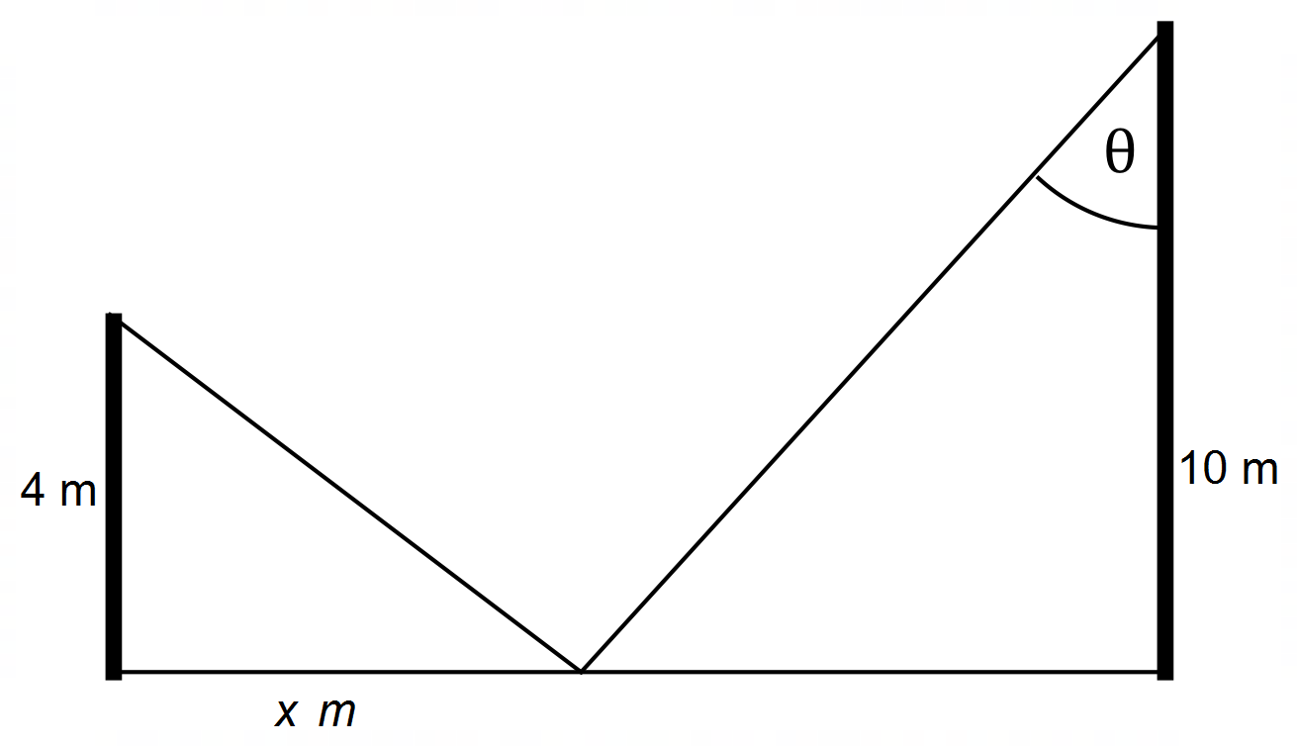to the anchor be *x* m.

(a) (i) Use Calculus to show that the minimum length of wire used occurs when:

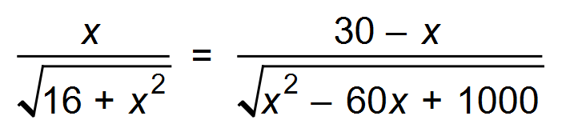 (4 marks)

(ii) Determine the value of *x* for this minimum to occur. (1 mark)

(b) Use the incremental formula 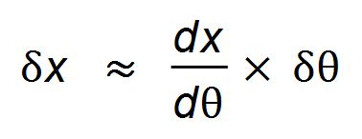 to determine the approximate change in the distance the anchor is from the smallest pole if θ decreases by 0.01R from the anchor point

found in (a). (5 marks)

**Question 12 (8 marks)**

The graph of y = f ′(x) is sketched below.

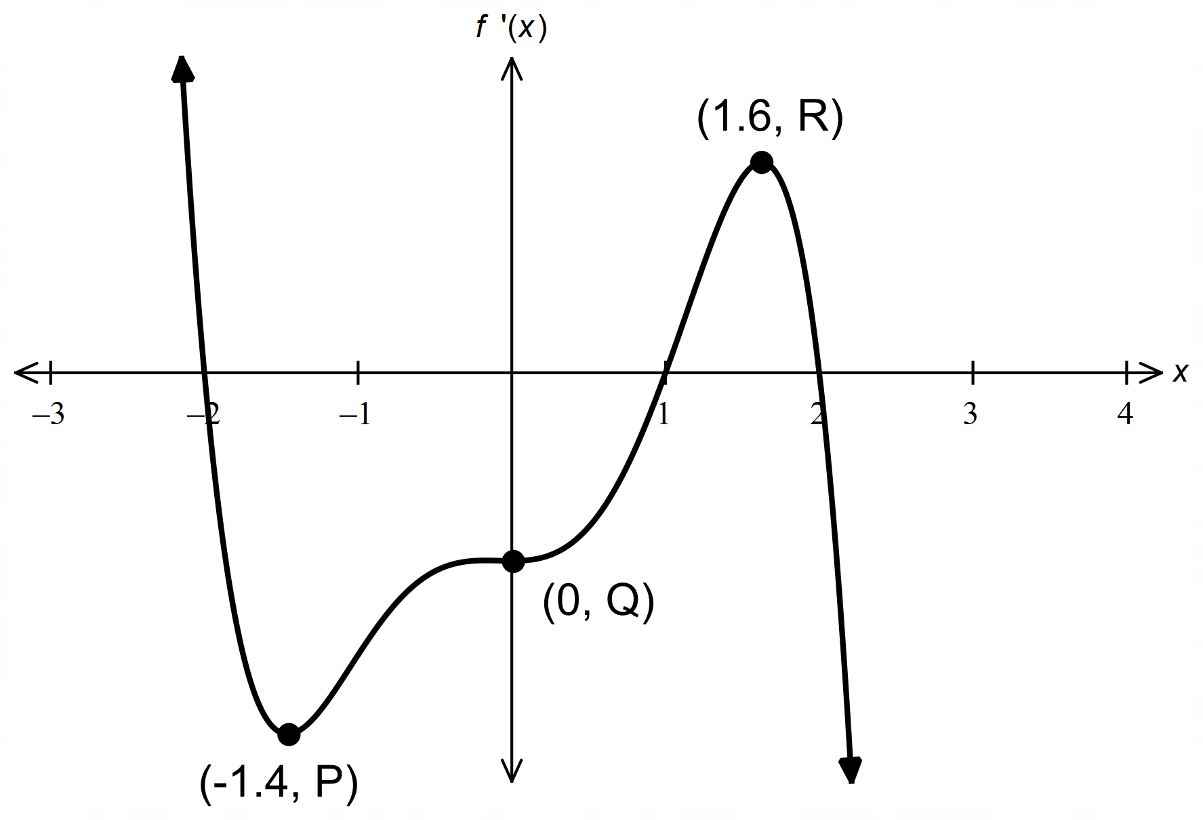

(a) State the values of x such that:

(i) f (x) is increasing. (2 marks)

(ii) f (x) is stationary. (2 marks)

(iii) f (x) is concave down. (2 marks)

(b) Determine the x−values of any oblique point(s) of inflection of y = f (x). (2 marks)

**Question 13 (8 marks)**

The amount of water, *W* (GL), in a reservoir is tracked over a twenty−four hour period.

The rate of change in the amount can be modelled by the equation 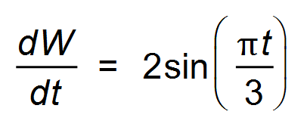,

where *t* is the number of hours after midnight. Initially the reservoir contains 3 GL of water.

(a) What is the rate of change in the amount of water in the reservoir at midday? (1 mark)

(b) Use Calculus to determine the exact amount of water in the reservoir at midday. (3 marks)

(c) Calculate the total change in the amount of water in the reservoir over the five hours between midnight and 5 am, correct to three decimal places. (2 marks)

(d) At what time, to the nearest minute, will the reservoir first contain more than 4 GL? (2 marks)

**Question 14 (13 marks)**

A computer is being used to crack the password codes of different mobile phones.

The probability that the computer can crack the codes of various phones is shown in the table below.

|  |  |
| --- | --- |
| Phone | Probability |
| Galaxy | 0.65 |
| iPhone 11 | h |

The programmer has been given five of each phone and asked to crack the codes of each.

(a) Explain why the experiment is Bernoulli if one phone is used. (1 mark)

(b) Determine the probability that the codes of:

(i) all the Galaxys are cracked. (2 marks)

(ii) only the first, third and fifth Galaxys are cracked. (2 marks)

(iii) at least two of the Galaxys codes are cracked. (2 marks)

(iv) none of the codes of the five iPhones are cracked. (2 marks)

(c) The probability that at least one iPhone code is cracked is 0.99757.

Determine, with working, the value of h. (2 marks)

(d) State the standard deviation of the distribution for cracking codes of the Galaxys. (2 marks)

**Question 15 (8 marks)**

The trigonometric function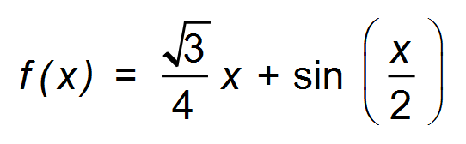is graphed below.

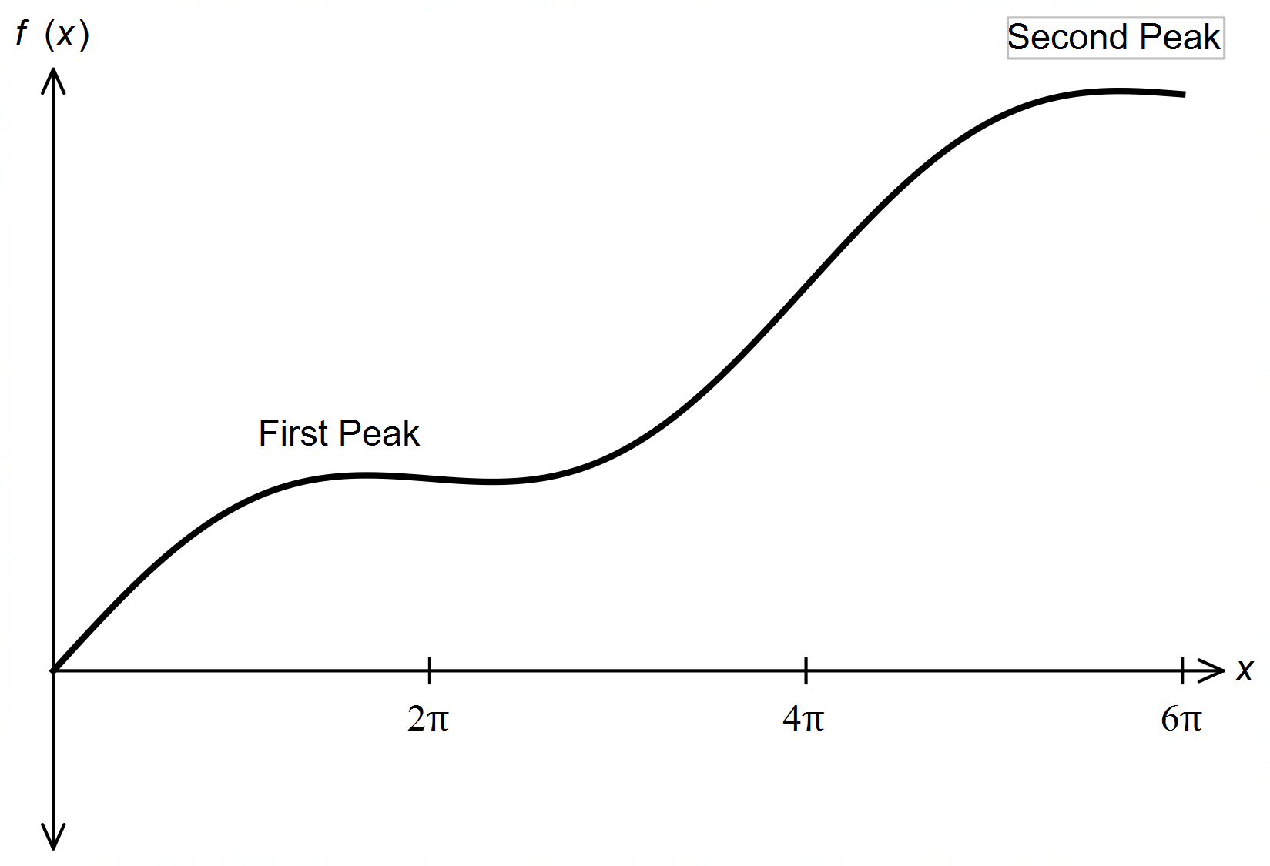

This function represents the height that the cars in the Daka Rally must conquer during

a section of the race. The distance, in kilometres from the starting point, is given by x and the

height, in metres above sea level, is given by f (x).

(a) Use Calculus to determine the exact distance from the starting point that the

first peak occurs, and the height above sea level that this occurs. (4 marks)

(b) Determine the maximum gradient, correct to two decimal places, after starting,

that the cars must overcome during this stage. (4 marks)

**Question 16 (9 marks)**

(a) Determine the derivative of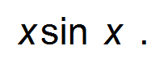 (2 marks)

Hence,

(b) (i) determine the antiderivative of xcos x. (3 marks)

(ii) 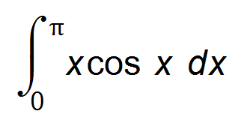. (2 marks)

(c) Determine the area bounded by the curve y = *x*cos *x* and the *x*−axis between

*x* = 0 and *x* = π, correct to two decimal places. (2 marks)

**Question 17 (9 marks)**

The random variable X has a pdf given by :



(a) What type of discrete random variable does X define? (1 mark)

(b) Determine:

(i) *k*. (1 mark)

(ii) P(*X* > 2 | *x* < 5). (1 mark)

(iii) E(*X*). (1 mark)

(iv) the exact standard deviation of the distribution. (2 marks)

A second distribution is defined to be *Y* = 3 − 2*X*.

(c) Determine:

(i) E(*Y*). (1 mark)

(ii) VAR(*Y*). (2 marks)

**Question 18 (6 marks)**

A particle, beginning at the origin, undergoes rectilinear motion such that its velocity

at any time *t* seconds is given by 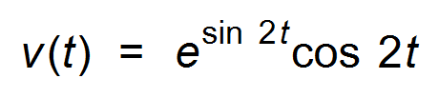 m/sec.

(a) Determine the exact distance the particle is from the origin at *t* =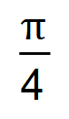seconds. (3 marks)

(b) What is the total distance travelled by the particle when its acceleration is zero

for the first time? (3 marks)

**End of questions**

**Additional working space**

Question number(s): ……………………

**Additional working space**

Question number(s): ……………………